**Name: saline k.b**

**Roll No:33**

**Batch:mca-B**

**Date:4-4-2022**

**NETWORKING & SYSTEM ADMINISTRATION LAB**

**Experiment No.: 5**

**Aim**

Familiarization with linux commands

**Procedure**

**1]copy**

**Description:Copy the content of one file to another file.**

**Cp marvel2 marvel5**

**Output Screenshot**

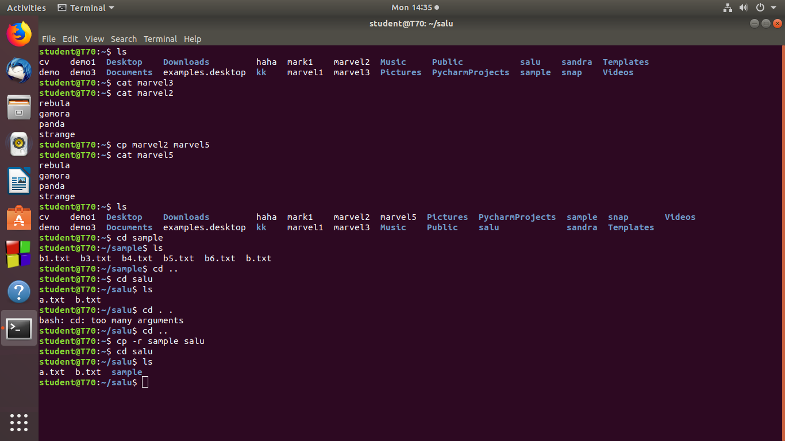

**Procedure**

**1.1]cp -r**

**Description:Copy one directory to another directory.**

**Cp –r sample salu**

**Output Screenshot**



**Procedure**

**1.2]cp -i**

**Description:used to asking the permission.**

**Cp –i p.txt sample**

**Output Screenshot**

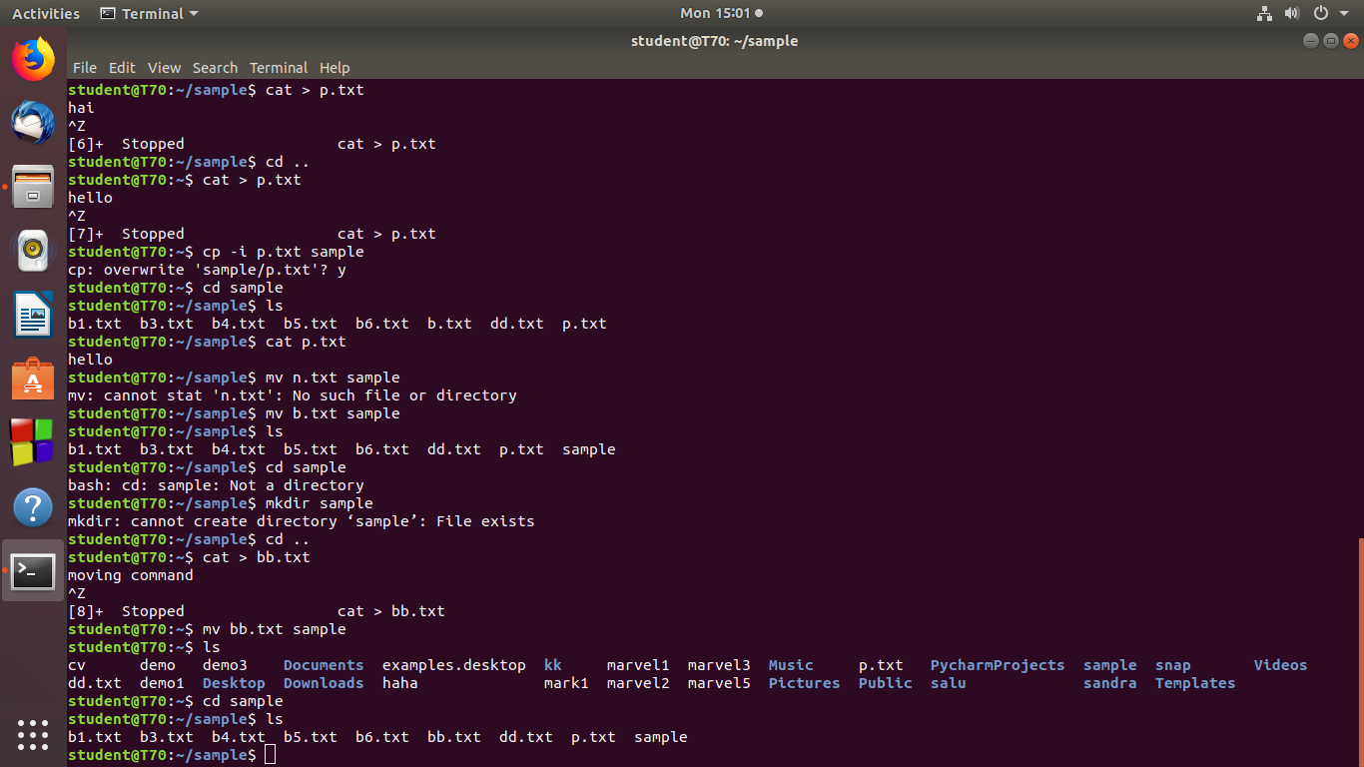

**Procedure**

**2]Move commands**

**Description:Move the entire file to next place and remove it from the current place.**

**mv move sample**

**Output Screenshot**

